Thank you — I’ve reviewed your PowerPoint thoroughly, including the layout, data visuals, and narrative. Here’s my **understanding** and **proposed plan** to create two highly visual, infographic-style summary slides — one for **Part 1** and one for **Part 2**:

**✅ UNDERSTANDING OF YOUR DECK**

**🧩**

**Part 1 – Real Estate Market Trends (2015–2025)**

* Spread across slides 3 to 10
* Contains multiple individual charts on:
  + Price/sqft trend
  + Transaction volume/value
  + Villa vs Unit price comparisons
  + Property type mix
  + Top 5 areas by value and count
  + Future outlook commentary

**Issue:** Currently too fragmented, aesthetically weak, and not cohesive.

**🧩**

**Part 2 – Developer Revenues & Key Projects (2015–2024)**

* Detailed in slides 13 and 15–19
* Covers:
  + Revenue data for top developers (Dubai and Abu Dhabi)
  + Key insights: growth trends, market share, strategic projects
  + Future outlook (2024)

**Issue:** Again, data is visualized in a slide-by-slide linear format, making it hard to absorb at a glance.

**🎯 GOAL: One Powerful Slide for Each Part**

You want **one unified dashboard-style slide per part**, using infographic thinking — merging key metrics, trends, and takeaways with clear visual hierarchy.

**💡 STRATEGY TO REDESIGN INTO 2 VISUAL DASHBOARDS**

**🔷**

**Slide 1: “UAE Real Estate Trends 2015–2025”**

**🔸 Suggested Layout (Infographic Style)**

**Title:** *“UAE Property Market – 10-Year Evolution at a Glance”*

| **Section** | **Visual Element** | **Content** |
| --- | --- | --- |
| **1. Price Evolution** | Smooth line graph or sparkline | Avg price/sqft (2015–2025) with key milestones tagged |
| **2. Transaction Volume & Value** | Dual-line mini chart or vertical bar icon set | Total transactions per year + value overlay |
| **3. Property Type Split** | Donut or 100% stacked bar | % split of Units, Villas, Land, Buildings |
| **4. Villa vs Unit Price Growth** | Two semi-circular gauges | Show % rise in villa & unit prices (2015–2025) |
| **5. Top Areas by Value & Count** | Heatmap or icon grid | Top 5 areas (2020–25): AED value + transaction count |
| **6. Forward Outlook** | Arrow box + brief quote | “Strong upward trend continues into 2030s, led by villas and high-demand zones” |

**🟨 Design Enhancements:**

* Use iconography for villas, units, buildings
* Color-code by property type (e.g., villas = green, units = blue)
* Highlight Palm Jumeirah / Marsa Dubai with pin-style icons

**🔷**

**Slide 2: “Top Developers: Revenue & Strategy Snapshot (2015–2024)”**

**🔸 Suggested Layout (Infographic Style)**

**Title:** *“UAE’s Real Estate Giants: Performance & Future Outlook”*

| **Section** | **Visual Element** | **Content** |
| --- | --- | --- |
| **1. Revenue Timeline (Dubai)** | Horizontal bar or area chart | Emaar, Damac, Nakheel, etc. with CAGR% |
| **2. Revenue Timeline (Abu Dhabi)** | Same format (separate cluster) | Aldar vs Q Properties |
| **3. Developer Comparison** | Market share pie or icon bars | Emaar = 34%, Aldar = 83% (per respective market) |
| **4. Strategic Project Milestones** | Timeline strip | Mark major launches like Dubai Hills Mall, Yas Bay |
| **5. COVID Impact** | Icon callout | Emaar: drop/recovery; Aldar: resilience data |
| **6. Outlook for 2024–25** | Arrow + summary box | “Mid-income communities driving 2024 growth: +8% expected” |

Perfect — here’s a **fully labeled layout blueprint** that mirrors the dashboard style you attached, adapted specifically for summarizing **Part 1 – UAE Real Estate Market Trends (2015–2025)**. You can **paste this into your working file** or hand it off to a designer as a clear creative brief.

**📊 UAE Real Estate Market Dashboard: 2015–2025**

**Slide Type:**

**Infographic Dashboard | 1-slide Summary of Key Trends**

**Style Reference: Based on the sample image from**

**Metricalist | Adjust App Analytics**

**🟥 HEADER**

**Title:**

“UAE Real Estate Market Dashboard: 2015–2025”

**Subtitle (optional):**

Updated using data across a decade of UAE real estate transactions, property trends, and buyer preferences.

**🟦 TOP ROW – KPI CARDS (Use same horizontal layout as image)**

| **Tile Label** | **Metric** | **Icon** | **Style** |
| --- | --- | --- | --- |
| 🏠 **Avg. Price per Sqft (2025)** | AED 1,420 (+52% from 2015) | Ruler icon 📏 | Number + sparkline |
| 🔁 **Total Transactions (2025)** | 94,000 | Repeat icon 🔁 | Number + mini trend line |
| 💰 **Total Value (2025)** | AED 270 Billion | AED icon 💵 | Number + delta change |
| 🏡 **Villa Price Growth** | +115% (2020–2025) | Villa icon 🏡 | Bar or % delta box |
| 📍 **Top Area by Value** | Palm Jumeirah – AED 125B | Palm tree 🌴 | Text + area icon |

🟨 *Tips:* Keep background white, use borders or light shadow. Include mini sparklines or ↑↓ arrows for visual trend cues.

**🟩 MIDDLE ROW – SEGMENTED CHARTS (4 quadrants in 2x2 layout)**

**📊**

**1. Property Type Mix (Donut Chart)**

* Donut split: Units (72%), Villas (16%), Land (11%), Buildings (1%)
* Add icons beside each category
* Caption: “Units dominate transactions; Villas show high-value interest.”

**📈**

**2. Villa vs Unit Price per Sqft (Dual Line Graph)**

* Line 1: Villas (sharp rise post-2020)
* Line 2: Units (gradual growth)
* Caption: “Villa prices surged post-COVID, reflecting buyer shift to spacious living.”

**🏙️**

**3. Top 5 Areas by Value (Bar Chart)**

* Y-axis: Palm Jumeirah, Marsa Dubai, Burj Khalifa, etc.
* X-axis: AED values
* Highlight % change (e.g., +45% Palm)
* Caption: “Premium zones attract the bulk of capital inflows.”

**📦**

**4. Top Areas by Transaction Count (Cluster Bar)**

* 2015–2020 vs 2020–2025
* Al Barsha South, Business Bay, etc.
* Caption: “New hotspots like Al Barsha South emerging fast.”

**🟨 BOTTOM ROW – QUALITATIVE INSIGHTS / OUTLOOK**

**📤**

**Outlook Box (Arrow or Highlight Box)**

“UAE property market entering 2025 with strong momentum – Villas and emerging zones expected to lead the next growth cycle.”

**💡**

**Key Insights Box (Bullet Summary)**

Use a soft blue background with icons:

* ✅ Units preferred for affordability; Villas for capital growth
* ✅ Land and building deals remain niche
* ✅ Buyer focus shifting to suburbs and mid-luxury developments
* ✅ Recovery post-2021 driven by economic rebound and policy shifts

**🖼️ DESIGN GUIDELINES**

* **Grid:** 3 rows → (KPI cards) + (quad charts) + (summary text)
* **Icons:** Use vector icons (home, tower, currency, chart arrows)
* **Colors:** Blue (units), Green (villas), Grey (land/buildings), Gold for standout data
* **Font:** Use Segoe UI, Montserrat, or Poppins for modern look
* **Tools:** Canva, PowerPoint SmartArt, or Figma (for advanced control)

**📌 Optional: Slide Footer**

Source: DLD transaction data, market reports, analyst curation

Prepared by: [Your Team Name]

Sample of a summary dashboard – summarising everything under Part 1

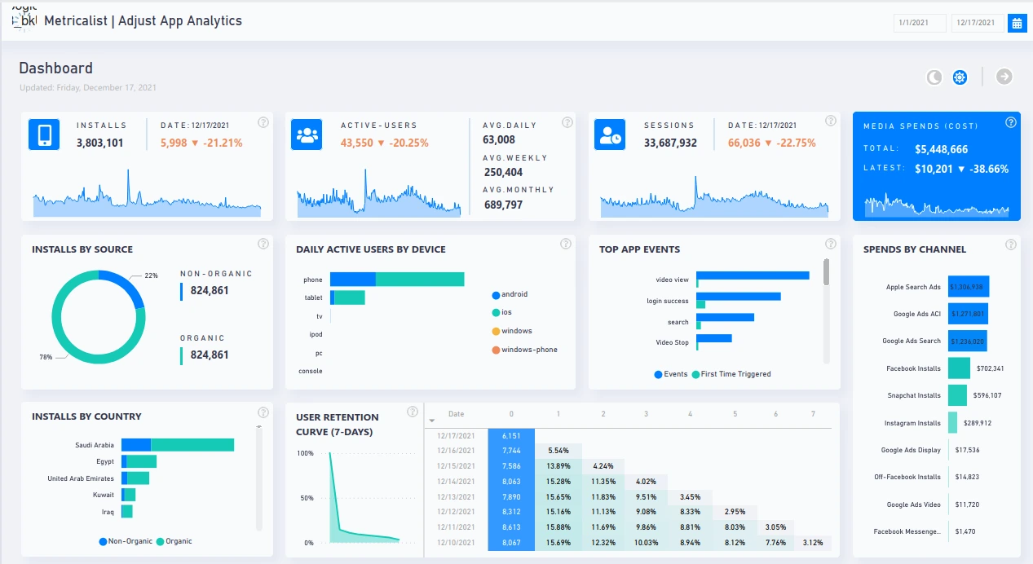

Excellent. Here’s the **fully labeled layout for Slide 2**, summarizing **Part 2 – Developer Revenue & Strategy Insights (2015–2024)** into a sleek, infographic-style dashboard — modeled after the same visual logic as your original reference image.

**🏗️ UAE Real Estate Developers Dashboard: 2015–2024**

**Slide Type:**

**Infographic Dashboard | 1-slide Summary of Developer Performance**

**Based on: Developer revenues, project launches, market share, and growth outlook**

**🟥 HEADER**

**Title:**

“UAE’s Top Real Estate Developers: Performance Dashboard (2015–2024)”

**Subtitle (optional):**

Snapshot of revenue growth, strategic launches, and market positioning of Dubai & Abu Dhabi’s leading developers.

**🟦 TOP ROW – KPI CARDS (Like app dashboard metric tiles)**

| **Tile Label** | **Metric** | **Icon** | **Style** |
| --- | --- | --- | --- |
| 🏗️ **Emaar Revenue (2023)** | AED 25.4B (34% of Dubai market) | Tower icon 🏢 | Number + market share ring |
| 🏙️ **Aldar Revenue (2023)** | AED 18.7B (83% of Abu Dhabi market) | Cityscape 🏙️ | Number + market share ring |
| 📈 **Post-COVID Growth** | +18% avg CAGR (2021–2023) across top 5 | Chart arrow | Highlighted % block |
| 📊 **Dubai vs AD CAGR (2015–2023)** | Dubai: 6.2% | AD: 5.8% | Comparison |
| 📆 **2024 Outlook (Forecast)** | +8% growth (driven by mid-income projects) | Calendar 📅 | Quote or colored box |

**🟩 MIDDLE ROW – STRATEGY & PERFORMANCE CHART ZONE (4 blocks, 2x2)**

**📉**

**1. Revenue Trends by Developer (Clustered Line/Bar)**

* X-axis: 2015–2024
* Y-axis: Revenue in AED M
* Series: Emaar, Damac, Nakheel, Aldar, etc.
* Caption: “Steady CAGR with post-2021 spike.”

**🏘️**

**2. Project Launch Timeline (Icon Strip with Years)**

* Timeline format with key project milestones:
  + 🏬 Dubai Hills Mall (2022 – Emaar)
  + 🏝️ Yas Bay (2023 – Aldar)
  + 🏘️ Saadiyat Villas (2024F – Aldar)
* Caption: “Revenue peaks aligned with mega project deliveries.”

**🏅**

**3. Developer Market Share (Pie or Icon Proportions)**

* **Dubai:** Emaar, Damac, Nakheel, Meraas, Dubai Properties
* **Abu Dhabi:** Aldar, Q Properties
* Caption: “Emaar and Aldar dominate city-level developer revenues.”

**🔄**

**4. COVID Impact Analysis (Before vs After Bar or Heatmap)**

* Compare 2020 drop and 2021–2023 rebound
* Highlight:
  + Aldar only dropped -17% (vs avg -25%)
  + Emaar rebounded 20%+
* Caption: “Govt-backed portfolios helped Abu Dhabi remain resilient.”

**🟨 BOTTOM ROW – QUALITATIVE STRATEGY INSIGHTS**

**📤**

**Outlook & Future Focus (Arrow Box)**

“2024 and beyond: Developer focus shifting from luxury to mid-income communities and suburban developments across Dubai South, Saadiyat, and Reem Islands.”

**💡**

**Key Strategic Insights (Icon Bullet Points)**

Use a light background box:

* 🔑 Emaar 3.1x bigger than Nakheel; reflects diversification edge
* 🏘️ Projects >AED 1B were key revenue drivers
* 🧩 Shift from ultra-luxury to mid-income (post-2020)
* 📍 Abu Dhabi developers show steadier long-term growth vs. Dubai volatility

**🖼️ DESIGN GUIDELINES**

* **Grid:** 3 clear zones (KPIs + mid-chart blocks + bottom insights)
* **Color coding:** Blue = Dubai devs, Green = Abu Dhabi devs, Yellow = Forecasts
* **Iconography:** Use branded colors or neutral blocks for developer icons/logos
* **Fonts:** Modern sans-serif (Poppins, Montserrat, or Segoe UI)

**📌 Footer (Optional)**

Source: Company annual reports (2015–2024E), DFM, ADX disclosures

Prepared by: [Your Firm Name] | Based on published/estimated data